HW#11 Name:_______________________
Test Review Date:______________Block:_____

1. Label each of the shapes below with the most specific name.

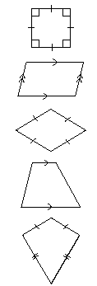

______________ ______________ ______________ ______________ ______________

Given the following properties, list ALL the quadrilaterals above that fit the description. If none, write NONE.

2. Opposite sides and angles are congruent.

3. Opposite sides are congruent.
All angles are congruent.

4. All sides are congruent.

5. Only one pair of parallel sides.
All angles are congruent.

Use the table to convert the following measurements.
Customary to Metric Customary to Metric
1 inch (in) ≈ 2.54 centimeters (cm) 1 pound (lb) ≈ 0.45 kilogram (kg)
1 foot (ft) ≈ 0.30 meter (m) 1 cup (c) ≈ 236.59 milliliters (mL)
1 yard (yd) ≈ 0.91 (m) 1 quart (qt) ≈ 946.35 milliliters (mL)
1 mile (mi) ≈ 1.61 kilometers (km) 1 gallon (g) ≈ 3.79 liters (L)

6. 5 km = _________ mi 7. 15 yd = __________ m

8. Which is greater? 6 ft or 18 m

9. Tommy needs 50 cm of fishing line to fix his pole. He only has a customary ruler on hand. How
many inches of fishing line does he need?

